The Georgetown Cup 2023
2nd September 2023
Velopreda

We will be doing the club photographs again this year so please form in your club groups over near the trees approx. half an hour before your first rider is off.

9am start. – sign on open from 8am.
Strip at Inchinnan Industrial Estate
Brownsfield Cres
Inchinnan
Renfrew PA4 9RH
All proceeds of this event will be split between our chosen charities.
The Georgetown Cup is an inter club challenge awarded to the cycling club team with the fastest 8 riders on combined time.
We have simplified the qualifying criteria this year. No ‘invitation only’ race teams can count for the team.
The Flying Scot competition is open to anyone riding on a genuine Rattray’s Flying Scot.

The Current course records are:
Fastest Team (8) - Glasgow Green 02:07:43 (2019)
Fastest Ladies Team (3) – Glasgow Green 55:48 (2019)
Fastest Male- John Archibald- 13.17 (2021)
Fastest Female- Katie Archibald – 14.49 (2021)
Fastest Flying Scot (owner) - Martin Wilson - VC Glasgow South -16.19 (2015)
Fastest Flying Scot (all comers)- John Archibald -14.35 (2019)
Fastest Ladies tandem - Laura Cluxton / Lynsey Carson 17.01 (2015)
Fastest Mens tandem – Graham Findlay / Gerrard Deeley (Johnstone Wheelers) 16:40 (2018)

Attempts on the Flying Scot record must be done using equipment available during the production years of the Flying Scot (pre 1983) No Tri-Bars – No deep section carbon wheels– no disc wheels. – Rider may use modern clipless pedals.
If you are riding a Flying Scot and aren’t listed on the sheet (FS) then please let us know as you sign on

Notes for competitors
There are no toilet facilities at the Strip. Please make use of toilets nearby e.g. Asda at Phoenix, Tesco at Linwood or Morrisons in Erskine. If you need to go behind a bush please do not do this anywhere near Georgetown Road, particularly round about the start area as this is a residential area. Anyone spotted doing this will be disqualified.

Competitor parking will not be allowed round the HQ area. There is ample parking within Inchinnan Industrial Estate. Please park further round to keep the HQ areas clear.

CLUB GAZEBOS
We welcome club gazebos being added to the tented village area. Please only erect your gazebos in the cordoned off area beside the main sign on. No club gazebos should be erected on the grass outwith this area.

Absolutely no cars to be brought onto Georgetown Road start/finish area and no parking in the car park of the Veterinary Surgery .

Due to congestion round the start area we will be restricting Georgetown Road to only those teams about to start. Please do your warm ups within Inchinnan Industrial Estate and only make your way round to the start at the appropriate time.

When finishing the race all competitors must immediately clear the Georgetown Road and not congregate round the finish area as this is disruptive to traffic flow, spoils people’s finishing efforts and disturbs the timekeepers.

Rider must under no circumstances approach the time keepers’ car and ask for their time. There will be Marshals at the start/finish area enforcing these rules. All times will be displayed within minutes of each team finishing on the result board round at the strip.

Flying Scot Rally
This years Flying Scot event will have awards for 1st 2nd and 3rd and also fastest Flying Scot.
The rally itself will have award for the ‘Best in Show’
Please support the Flying Scot Rally and please give generously.

COURSE
Map of Course

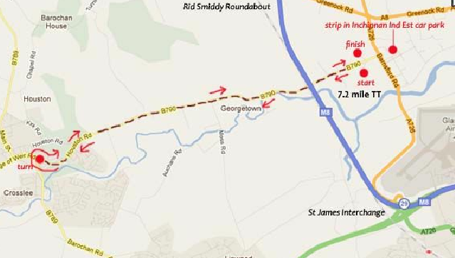

There is a toucan pedestrian crossing close to the turn. We will have marshals in place at the crossing and also a timekeeper who will make an adjustment to your overall time if you have to stop. All riders must obey the crossing lights and any rider failing to do so will be disqualified.

We would also draw your attention to the Risk Assessment. There are several sharp bends on the course which can be approached at high speed. Riders should be aware of these and adjust their speed accordingly. We have placed signage at the approach to these bends.

